**Datum Labs Assessment**

**Python Questions:**

**1.**

def fill_none_value(array): #function definition with array as #argument

  if len(array) == 0: # handling a case for length of array=0

    return f"List is empty"

  else:

    for i in range(len(array)):

      if(array[i] == None):

        array[i] = array[i-1] # if current element is None then #fill with the last element

      if (array[0] == None):

        array[i] = array[i+1]

    return array

array1 = [None,2,3,None,None] #function usage

fill_none_value(array1)

**Code output:**

**[2, 2, 3, 3, 3]**

**2.**

def split_and_return_list(string1, string2): #function declaration #taking two strings as arguments.

    words1 = string1.split() #list

    words2 = string2.split() #list

    mismatched_Words = []

    for i in range (len(words2)): #condition checking the case.

      if (words1[i]  != words2[i]):

        mismatched_Words.append(words1[i])

    return f"{mismatched_Words}"

# Example usage

input_string = "This is a sample string" #defining string

input_string1 = "THIS IS A sample string" #defining string

split_and_return_list(input_string, input_string1) #function usage

**Code output:**

**['This', 'is', 'a']**

**3.**

def get_char_frequency(str): #function definition

  frequency = {} #deifining of dictionary

  for i in str: #increment each character in the string

    if i in frequency:

      frequency[i] += 1

    else:

      frequency[i] = 1 #if not present then make frequency to one.

  return f"Frequency of each character in list is {frequency}"

def get_specific_char_frequency(str, char): #function for computing #frequency of specific character.

  count = 0

  for i in str:

    if i == char:

      count += 1

  return f"Count of {char} in string {str} is {count}"

my_string = "This is This is usman usman"

get_specific_char_frequency(my_string,"i")

**Code ouput:**

**Count of i in string This is This is usman usman is 4**

**SQL Questions:**

**1.**

SELECT

customers_with_both_paid,

total_unique_customers.unique_customers,

ROUND((customers_with_both_paid * 100.0 / total_unique_customers.unique_customers), 2) AS percentage

FROM (

SELECT

COUNT(DISTINCT cp1.customer_id) AS customers_with_both_paid

FROM

CustomerPurchases AS cp1

WHERE

cp1.product_id = 'ProductA'

AND cp1.payment_status = 'Paid'

AND EXISTS (

SELECT 1

FROM CustomerPurchases AS cp2

WHERE cp1.customer_id = cp2.customer_id

AND cp2.product_id = 'ProductB'

AND cp2.payment_status = 'Paid'

)

) AS customers_with_paid_number,

(

SELECT

COUNT(DISTINCT customer_id) AS unique_customers

FROM

CustomerPurchases

) AS total_unique_customers;

**Code output:**

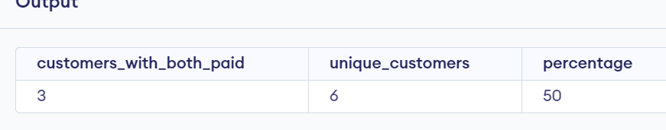

**3.**

SELECT

cp.product_id AS complementary_product_id,

COUNT(*) AS frequency

FROM

CustomerPurchases cp

JOIN

CustomerPurchases cp_a ON cp.customer_id = cp_a.customer_id

WHERE

cp_a.product_id = 'ProductA'

AND cp.product_id <> 'ProductA'

GROUP BY

cp.product_id

ORDER BY

frequency DESC

LIMIT 5;

**Code output  
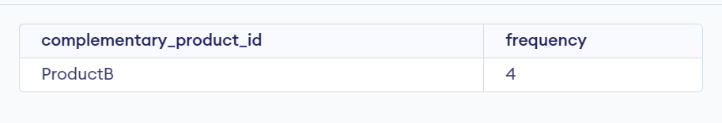**

**Dbt Question:**

**The following is the screenshot of the overall environment.**

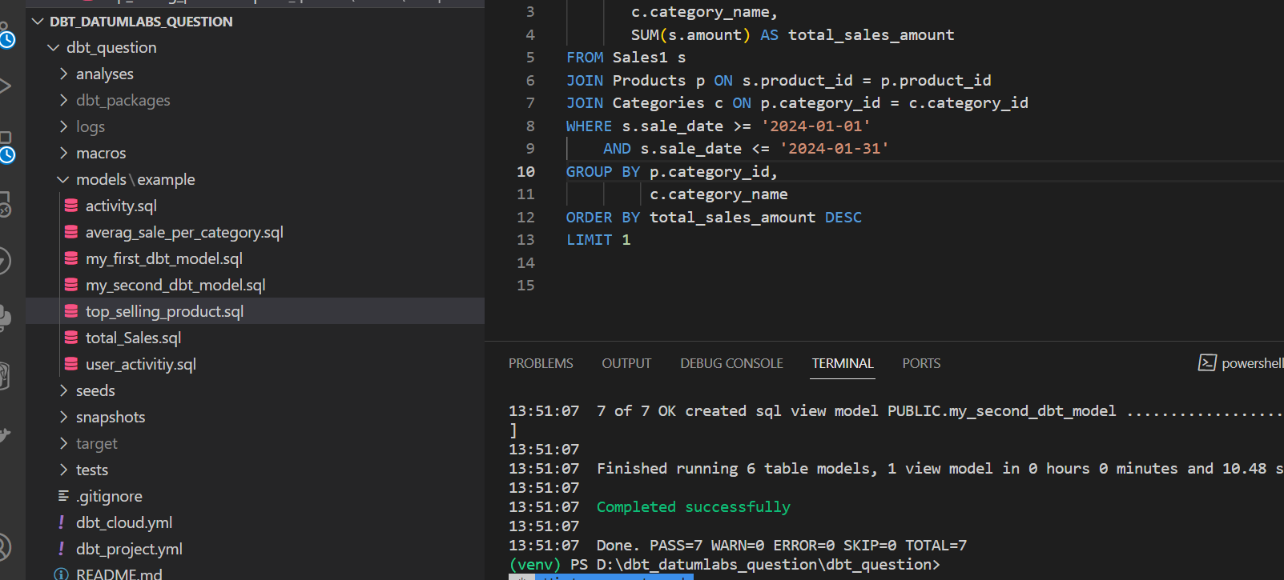

**1.**

{{ config(materialized='table') }}

SELECT COUNT(DISTINCT user_id) AS active_users

FROM USERACTIVITY

WHERE activity_date >= '2024-01-01' and activity_date <= '2024-01-30'

**Code output in the snowflake database  
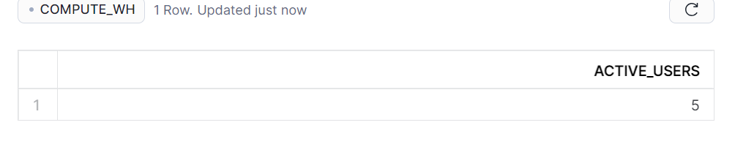**

**2.**

{{ config(materialized='table') }}

SELECT SUM(amount) AS total_sales_revenue

FROM Sales

WHERE sale_date >= '2024-01-01'

    AND sale_date <= '2024-01-31'

**Code output:  
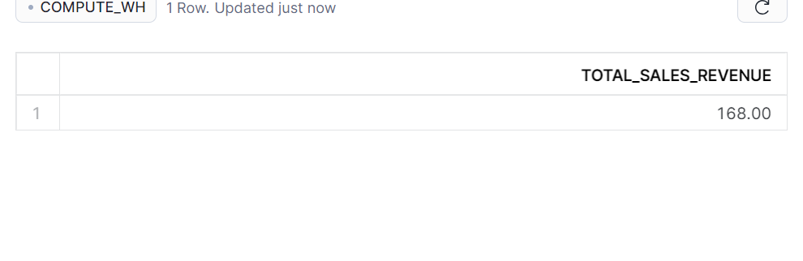**

**3.**

{{ config(materialized='table') }}

SELECT category_id,

       AVG(amount) AS average_sale_amount

FROM SALES1

GROUP BY category_id

**Code output:**

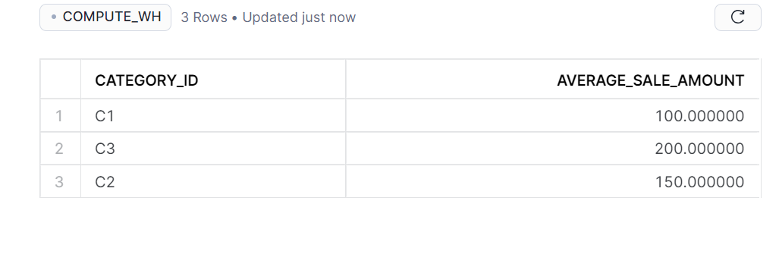

**4.**

{{ config(materialized='table') }}

SELECT user.user_id,

       user.user_name,

       activity.activity_id,

       activity.activity_date,

       user.join_date

FROM USERACTIVITY activity

JOIN USERS user ON user.user_id = activity.user_id

WHERE user.join_date >= '2024-01-01'

    AND user.join_date <= '2024-01-31'

**Code output:  
No output as there were no users who joined in the January.**

**5.**

{{ config(materialized='table') }}

SELECT p.category_id,

       c.category_name,

       SUM(s.amount) AS total_sales_amount

FROM Sales1 s

JOIN Products p ON s.product_id = p.product_id

JOIN Categories c ON p.category_id = c.category_id

WHERE s.sale_date >= '2024-01-01'

    AND s.sale_date <= '2024-01-31'

GROUP BY p.category_id,

         c.category_name

ORDER BY total_sales_amount DESC

LIMIT 1

**Code output:**

